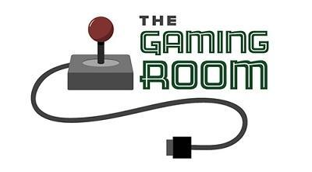

<Draw It or Lose It>

CS 230 Project Software
Version 1.0

Table of Contents

CS 230 Project Software Design 1
Table of Contents 2
Document Revision History 2
Executive Summary 3
Requirements 3
Design Constraints 3
System Architecture View 3
Domain Model 3
Evaluation 4
Recommendations 5

Document Revision History

Version | Date | Author | Comments
1.0 | 10/6/26 | Angel Gioletti | Software design and operating systems evaluation

Executive Summary

The Gaming Room currently offers Draw It or Lose It as an Android game and wants to expand it to Windows, macOS, Linux, Android, and iOS. The application needs to support thousands of players while providing a consistent gaming experience across different devices. I recommend using a Linux server to host the application and a responsive web interface that players can access through their browsers. This approach would reduce development costs, simplify maintenance, and allow the company to expand to additional platforms. The application will also need reliable network communication, secure data storage, and enough server resources to handle multiple games running at the same time.

Requirements

The Gaming Room needs a web-based version of Draw It or Lose It that works on desktop computers and mobile devices. The game consists of four rounds lasting one minute each, with an additional guessing opportunity for remaining teams when the original time expires. The application must manage players, teams, scores, drawing clues, and timers while supporting thousands of users. It must work across Windows, macOS, Linux, Android, and iOS through modern web browsers. The system also needs secure communication, reliable data storage, and a design that can grow as the number of players increases.

Design Constraints

The application must work across different operating systems and browsers without requiring a completely separate application for every platform. This means CTS needs to use compatible web technologies and test the interface on different devices. Another constraint is the number of users the server must support. The system must manage network traffic, game sessions, and database requests without slowing down. The application must also protect user information and maintain accurate game timers and scores. These requirements make server-side game management, responsive design, security, and scalability important parts of the development process.

System Architecture View
The application will use a client-server architecture. Players will access Draw It or Lose It through a web browser on their desktop or mobile devices. The browser will communicate with a central server that manages game sessions, teams, scores, and round timers. A database will store player and game information, while REST APIs and WebSockets will allow the client and server to exchange information. This design keeps the main game logic on the server and allows players using different operating systems to participate in the same game. Additional server resources can be added as the number of players grows.

Domain Model
The domain model represents the main objects involved in The Gaming Room application and how they relate to one another. The Game object represents an individual game and maintains a list of Teams participating in that game. Each Team maintains a list of Players, and each Player represents an individual participant. The Entity class serves as the parent class for Game, Team, and Player, providing common attributes such as a unique ID and name. The GameService class manages the collection of games and provides methods to add and retrieve games, track the number of games, and generate unique IDs for teams and players. The Singleton pattern ensures that only one shared instance of GameService is used throughout the application.
These relationships demonstrate object-oriented programming principles such as encapsulation, abstraction, and inheritance. Encapsulation keeps related data and behavior together within each class, while abstraction allows developers to interact with objects through their methods without needing to understand every internal detail. Inheritance allows Game, Team, and Player to share common properties and methods through the Entity superclass. The Singleton pattern also provides a centralized way to manage game-related operations. Organizing the application this way makes the code easier to maintain and helps CTS expand the system with new features without rewriting the entire application.

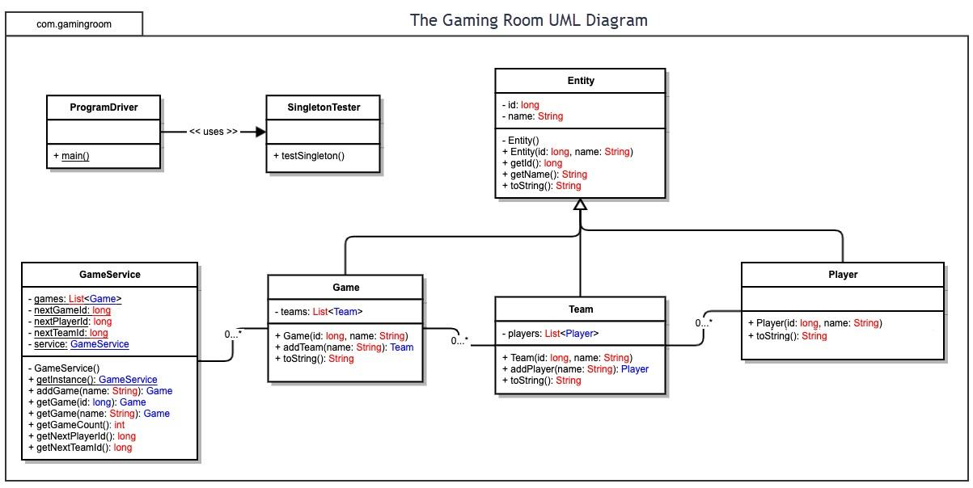

Evaluation

The following evaluation compares macOS, Linux, Windows, and mobile devices based on server hosting, client compatibility, and development tools.

Development Requirements | Mac | Linux | Windows | Mobile Devices
Server Side | macOS can host web applications, but it is primarily designed for desktop use rather than large-scale production servers. It supports common programming languages and development tools, but Apple hardware can be expensive. It is better suited to development and testing than hosting a game expected to support thousands of players. The operating system does not usually require a separate license when included with supported Apple hardware, but hardware and maintenance costs still apply. | Linux is my first choice for hosting the application because it is reliable, flexible, and cost-effective. Distributions such as Ubuntu Server and Debian are available for free and support web servers such as Apache and Nginx. Linux also works with Java, Docker, and cloud hosting services, making it easier to scale the application as the number of players increases. Its main disadvantage is that the development team needs experience with server administration, security, and maintenance. Commercial support and cloud hosting may also involve additional costs. | Windows Server is another suitable option. It supports Internet Information Services (IIS), C#, and .NET, and integrates with Microsoft Azure. These features make it a good choice for companies that already use Microsoft technologies. However, Windows Server generally requires a paid license, and additional expenses may include client access licenses and support services. The team may also need experience managing Windows servers. | Android and iOS devices should be used to access the game rather than host the central application. Mobile devices have limited processing resources, battery constraints, and restrictions on background activity. They are not suitable for managing thousands of connected players. The back-end application should run on a dedicated server, while mobile devices communicate with it through a browser.
Client Side | Players using macOS should be able to access the game through browsers such as Safari, Chrome, and Firefox. A responsive HTML interface would eliminate the need for a separate desktop application. CTS will need to test browser compatibility and make sure the interface works correctly on different screen sizes. Safari may behave differently from other browsers, so additional testing could increase development time slightly. | Linux users can access the game through supported browsers such as Firefox and Chrome. Using HTML5, CSS3, and JavaScript or TypeScript would allow CTS to support Linux without developing a separate native application. The main considerations are differences in browser versions and system configurations. Cross-browser testing will require time and technical knowledge, but the shared codebase should keep overall costs manageable. | Windows supports common browsers such as Chrome, Firefox, and Microsoft Edge. A browser-based application would allow players to access the game without installing separate desktop software. CTS should test the interface across supported browsers and verify that keyboard controls, display layouts, and network communication work properly. Using the same web technologies as the other desktop platforms will reduce development time and duplicated work. | Android and iOS users should be able to access the game through responsive mobile browsers. The interface must support touch controls, smaller screens, and different device orientations. CTS will need to test on multiple devices because screen sizes, browser behavior, and network conditions vary. Developing one shared web application should cost less than maintaining separate native Android and iOS applications, although device testing will still require time and resources.
Development Tools | CTS can use Visual Studio Code, IntelliJ IDEA, Git, and browser developer tools to develop and test the web application on macOS. Xcode and Safari Web Inspector can help with Apple-specific testing. Most of these tools are free, but Apple hardware is required for macOS development, and certain Apple developer services require paid membership. Native Swift development would only be necessary if the company later decides to create a separate iOS application. | Java and Spring Boot could be used to develop the back-end application. Developers could use IntelliJ IDEA, Eclipse, or Visual Studio Code, along with Git for source control and Docker for deployment. Apache or Nginx could handle web traffic. Many of these tools are free or open source, although commercial software, support services, and cloud hosting may add costs. The team needs Linux administration skills to configure and maintain the production environment. | CTS could use Visual Studio, C#, .NET, PowerShell, and IIS if it chooses a Microsoft-based server architecture. Visual Studio Code and Git are also useful for general web development. Some tools have free versions, while certain editions and enterprise services require payment. Windows Server licensing must be considered separately from development tool costs. Developers would need experience with the Microsoft environment if these technologies were selected. | The client interface can be built with HTML5, CSS3, and JavaScript or TypeScript. Android Studio and its emulators can help test Android devices, while Xcode simulators and Safari Web Inspector can help test Apple devices. Playwright can automate browser testing across supported environments. Most of these tools are free, but physical devices and commercial testing services may add expenses. A shared web application means CTS does not necessarily need separate native development teams for Android and iOS.

Recommendations

Analyze the characteristics of and techniques specific to various systems architectures and make a recommendation to The Gaming Room. Specifically, address the following:

- Operating Platform: I recommend using Linux to host Draw It or Lose It because it is reliable, flexible, and affordable. Linux supports many of the tools needed to run a web application, and distributions such as Ubuntu Server and Debian are available without an operating system licensing fee. The Gaming Room will still need to consider hosting, maintenance, and support costs, but Linux is a good option for a game that needs to support thousands of players. I also recommend making the game available through a web browser. This would allow players to access it from Windows, macOS, Linux, Android, and iOS without having to install a separate application for each platform. The server would handle the main game functions, including players, teams, scores, and timers, while the browser would display the game to each user. This approach would make the application easier to maintain and help reduce development costs as The Gaming Room expands to more platforms.

- Operating Systems Architectures: Linux is designed to manage multiple programs and users at the same time. Its kernel handles important tasks such as managing memory, running processes, communicating with hardware, and controlling access to system resources. These features make it a good choice for hosting a game that may have many active players and game sessions. For Draw It or Lose It, the development team could use Java and Spring Boot to build the server-side application. Nginx could handle incoming web traffic and forward requests to the application. A database would store information such as player accounts, teams, scores, and game results. Keeping these parts separate would make the system easier to manage and update. Linux also supports tools such as Docker, which allows developers to package the application and the software it needs into containers. This can make it easier to test the game and move it between development and production environments. If the number of players increases, The Gaming Room could add more application instances to handle the extra traffic. This would allow the system to grow without requiring the entire application to be rebuilt.

- Storage Management: I recommend using PostgreSQL to store game information and a separate object storage system for the image library. PostgreSQL is a good choice for keeping track of players, teams, scores, and game sessions because it organizes information into related tables. It can also help maintain accurate records when multiple players are using the application at the same time. The image library will require a significant amount of storage. The Gaming Room expects to have 200 high-definition images, with each image taking up about 8 megabytes. This means the entire collection will require approximately 1,600 megabytes, or 1.6 gigabytes, of storage. Additional space will be needed for the application itself, database records, logs, temporary files, and backups. The system should have enough extra capacity to accommodate future updates and additional images. Storing images separately from the database would make them easier to manage. PostgreSQL could keep information about each image, such as its file location, category, and the puzzle it belongs to, while the actual image would be stored in object storage. The application could then retrieve an image when it is needed for a round. A caching system or content delivery network could also help images load faster, especially when players are located in different areas. The Gaming Room should regularly back up important game information and monitor available storage space. These steps would help prevent data loss and make it easier to maintain the application as it grows.

- Memory Management: Memory management is important because Draw It or Lose It needs to display images quickly while multiple games are running at the same time. Linux uses virtual memory to give each process its own address space and manage how physical memory is used. It also uses demand paging, which allows memory pages to be loaded when they are needed instead of requiring everything to be loaded at once. Linux can use swap space when RAM becomes limited, although relying too much on swap can slow the application down. Even though the image library requires about 1.6 gigabytes of storage, the game does not need to keep all 200 images in RAM. Loading every image at once would waste memory and could affect performance, particularly when many games are active. Instead, the application should load only the images needed for the current round and remove them from memory when they are no longer being used. The game could also use caching to keep frequently used images available for a short time. This would help reduce loading delays without using too much memory. Images should be resized when appropriate so that the application does not use more memory than necessary to display them. Developers should also monitor memory usage and test the application with many simultaneous players to see how it performs under pressure. The server is not the only part of the system that needs to manage memory. Players will be viewing the game through browsers, and some of them may be using phones or tablets with limited RAM. The web application should avoid loading unnecessary images and should release resources that are no longer needed. These steps would help the game run smoothly across desktop and mobile devices.

- Distributed Systems and Networks: Since Draw It or Lose It needs to work across several operating systems, I recommend using a client-server architecture. Players would connect through their web browsers, and a central server would manage the game and keep track of what is happening. This would allow someone using an iPhone to play with someone using a Windows computer without needing different versions of the game. The application could use REST APIs to handle requests such as joining a game or retrieving player information. WebSockets would be useful for sending real-time updates, including score changes, timer updates, and the beginning or end of a round. The server should keep track of the official game state so that all players see the same scores and remaining time. Network problems are another issue the development team needs to consider. A player might lose their internet connection during a round, or the server might temporarily become unavailable. The application should be able to reconnect players and retrieve the current game state when possible. The server should also validate guesses and score changes rather than trusting information sent directly from a player's device. If the game becomes more popular, a load balancer could distribute incoming traffic across multiple servers. The servers would need access to shared game information so players connected to different servers could still participate in the same game. Monitoring the system, maintaining backups, and having a recovery plan for outages would help keep the game available. These measures would make the application more reliable as the number of players increases.

- Security: Security is important because Draw It or Lose It will manage player information and allow users to connect over the internet. Linux includes security features such as user permissions, firewalls, and process isolation that can help protect the server. The Gaming Room should keep the operating system updated, disable unnecessary services, and limit administrative access to authorized staff. The application should use HTTPS to protect information traveling between the player's browser and the server. User accounts should be protected with secure authentication, and passwords should never be stored as plain text. The system should also check user input and verify that players are allowed to perform the actions they request. For example, a player should not be able to change their score by sending a modified request to the server. The database should only be accessible to the application services that need it, rather than being exposed directly to the internet. Access permissions should be limited, and sensitive configuration information should be stored securely. Backups should also be protected so that player and game information cannot easily be accessed by unauthorized people. Another important part of security is keeping the game fair. The server should control the official timers, verify guesses, and calculate scores instead of relying on the player's device. This would make it harder for someone to manipulate the game. Regular security updates, testing, and monitoring would help the development team identify problems before they become serious. By combining Linux's security features with these additional protections, The Gaming Room can provide a safer and more dependable gaming experience across all supported platforms.

